V1.0.20250411-0838

Setting up Neurosync And Neurosync POST Server

1. Windows
2. Neurosync
3. Unreal Engine
4. Social Stream Ninja

This setup is tested with Nvidia 3050(Laptop) and Nvidia 4060ti(Desktop) .

Setting up Windows
Before we start to install Neurosync and Social Stream Ninja, there are a couple of things you need to install to Windows.

A. Python 3.12.10
Yes, Yes I know there is newer versions of Python but this is the version you need to make everything work. Atleast this is what I ended up using to get everything to work...

B. Nvidia Cuda (cuda_12.8.1_572.61_windows.exe)

!! OBS !!
A full install of Neurosync like I have it set up takes about 20GB of disc space.

You need to configure Elevenlabs and such aswell but I wont cover that at this point.
This is ONLY the basic setup.

Neurosync

There are a couple of things you have to download. But before you download anything lets get organized.

Make a folder where you want to have your Neurosync files. Below is an example. For now just make the Neurosync folder.

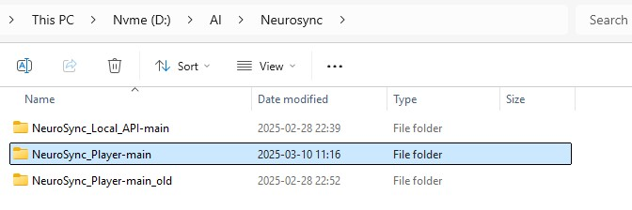

Download and extract the following packages.
Neurosync_Player
Neurosync_Local_API
Neurosync_Real-Time_API

After you have extracted the files if you go into each extracted folder you will find another folder.

Example for Neurosync_Local_API :

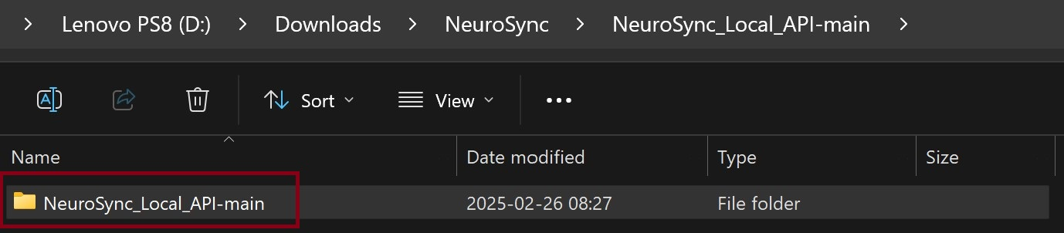

copy those folders from each extracted file to The Neurosync folder you made in part 3 and after that it should look something like this below.

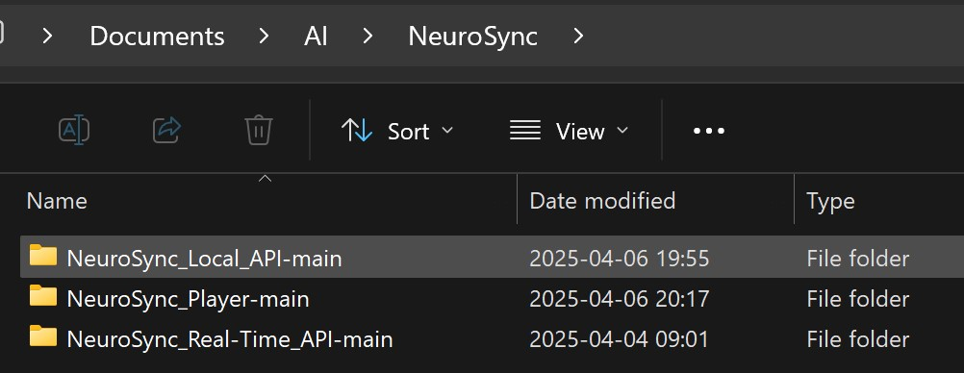

Creating the virtual enviroments (venv)
For those wondering why im not using requirements.txt , it´s because for some reason some packages cant be installed using requirements.txt. I am working on finding a way to make it work with requirements.txt but for now this is how I do it.

Neurosync_Local_API-main

Now go into the folder Neurosync_Local_API-main and run

python -m venv api
then run
api\Scripts\activate

Now it should look like this
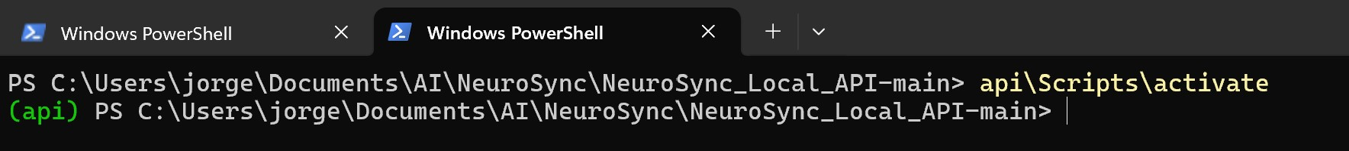
Now run :
pip3 install flask
pip3 install numpy
pip3 install librosa
pip3 install torch torchvision torchaudio --index-url https://download.pytorch.org/whl/cu118

Now run python neurosync_local_api.py to test if everything is working. If it works it should look something like this :

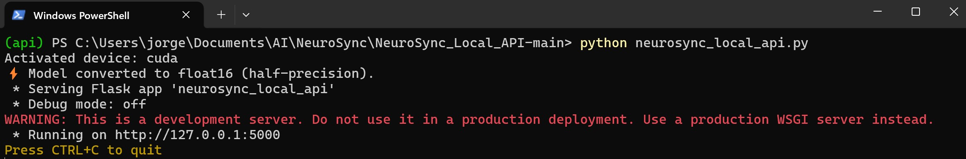

NeuroSync_Player-main

Start a new Powershell but for NeuroSync_Player-main. In the NeuroSync_Player-main folder run :

python -m venv async
then run
async\Scripts\activate

Download the POST Server HERE to NeuroSync\NeuroSync_Player-main\

Now run :
pip3 install pygame
pip3 install requests
pip3 install timecode
pip3 install numpy
pip3 install pandas
pip3 install soundfile
pip3 install scipy
pip3 install librosa
pip3 install keyboard
pip3 install pyaudio
pip3 install pydub
pip3 install flask
pip3 install google-generativeai (if you gonna use Google Gemini)
pip3 install -q kokoro>=0.9.4 soundfile (if you use Local Kokoro TTS)

Now run
T2FA.py --web
to test if everything is working.

If it works it should look something like this :
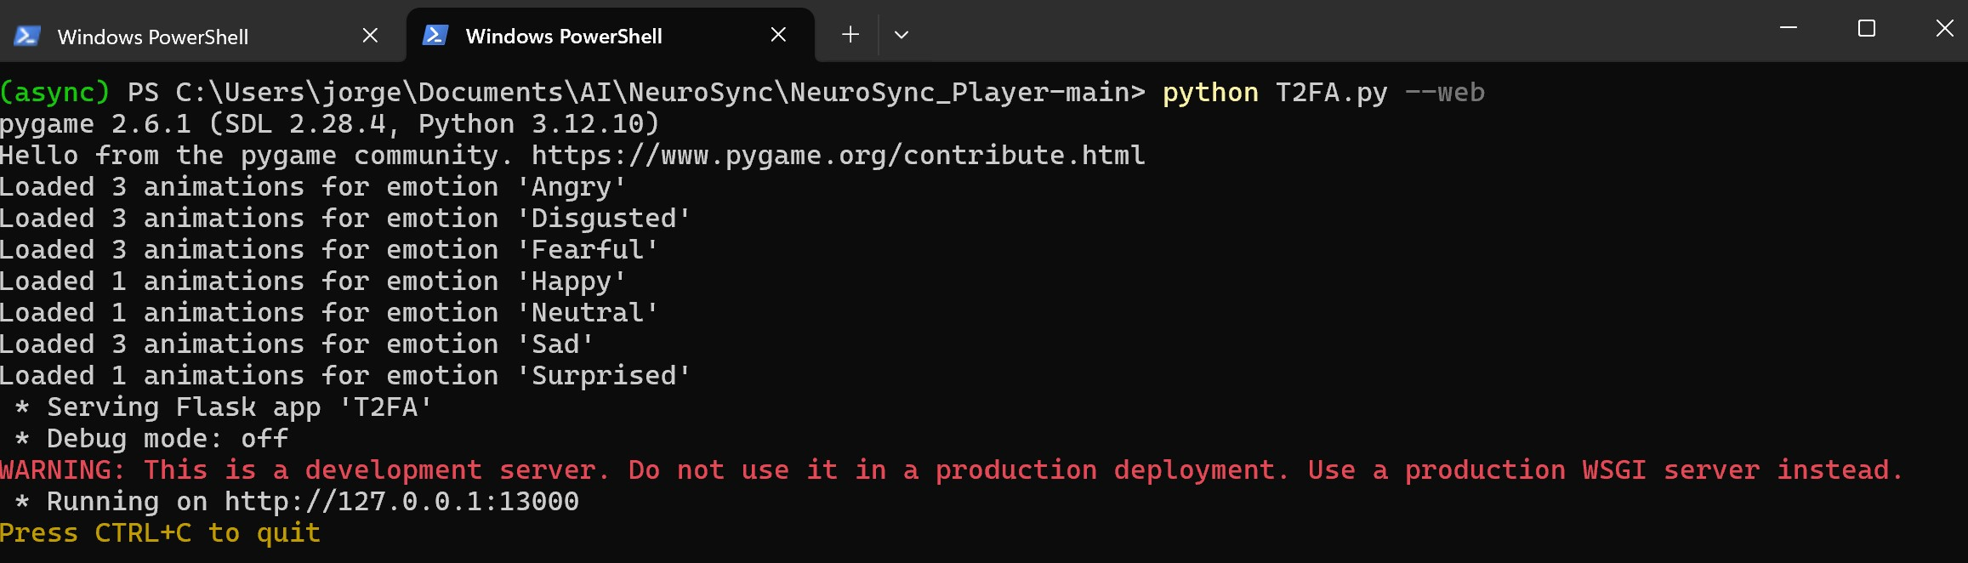
To test the POST server (T2FA.py) download POST_Demo.html to any folder and open it in Chrome. If you click on any of the messeges on that page the POST server should react and then the API should react. If they do, you know the POST server is working.

Now you can either try the NeuroSync_Player-main
python play_generated_files.py - Plays audio according to the number specified.
python push_to_talk_to_face.py - Records audio and sends it to the API, then returns it to Unreal.
text_to_face.py - Enter text that will be converted into audio using ElevenLabs and returned to Unreal on the MetaHuman.
wave_to_face.py - Enter the directory of a .wav audio file to send it to the MetaHuman.

or continue with the installation of NeuroSync_Real-Time_API-main.

NeuroSync_Real-Time_API-main

Start a new Powershell but for NeuroSync_Real-Time_API-main. In the NeuroSync_Real-Time_API-main folder run :

python -m venv rtapi
then run
rtapi\Scripts\activate

Now run :
pip3 install thread
pip3 install flask
pip3 install datetime
pip3 install torch torchvision torchaudio --index-url https://download.pytorch.org/whl/cu118
pip3 install soundfile
pip3 install resampy
pip3 install librosa
pip3 install transformers
pip3 install kokoro
pip3 install sentence_transformers

Download:
https://huggingface.co/AnimaVR/NEUROSYNC_Audio_To_Face_Blendshape/blob/main/model.pth
to NeuroSync_Local_API-main\utils\model.

Copy model.pth to NeuroSync_Real-Time_API-main\models\neurosync\model

Download
https://github.com/AnimaVR/NeuroSync_Real-Time_API/blob/main/models/neurosync/model/model.py
to NeuroSync_Real-Time_API-main\models\neurosync\model

https://huggingface.co/Snowflake/snowflake-arctic-embed-m-v1.5/blob/main/model.safetensors
to NeuroSync_Real-Time_API-main\models\arctic_embed

https://huggingface.co/openai/whisper-large-v3-turbo/blob/main/model.safetensors
to NeuroSync_Real-Time_API-main\models\whisper_turbo

https://huggingface.co/Salesforce/blip-image-captioning-large/blob/main/model.safetensors
to NeuroSync_Real-Time_API-main\models\vision\blip-image-captioning-large

https://huggingface.co/openai/clip-vit-large-patch14/blob/main/model.safetensors
to NeuroSync_Real-Time_API-main\models\vision\clip-vit-large-patch14

https://huggingface.co/dandelin/vilt-b32-finetuned-vqa/blob/main/pytorch_model.bin
to NeuroSync_Real-Time_API-main\models\vision\vilt-b32-finetuned-vqa

Now run
main.py --web
to test if everything is working. On the first run it will automaticly download the model for Kokoro.

If it works it should look something like this :

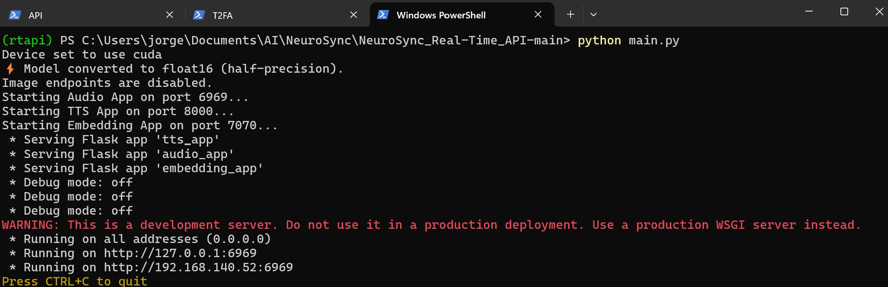

Try the NeuroSync_Player-main

If you want to test the Neurosync servers with an Unreal Engine project you can download NEUROSYNC_Demo_Build.zip

If you want to test the Neurosync servers in Unreal Engine you can download NEUROSYNC_Demo_Project.zip . When you have downloaded and extracted the project to your Unreal Engine Project folder open the project.

Now configure the MetaHuman to connect with NEUROSYNC.
Click on the character and in the settings panel find :
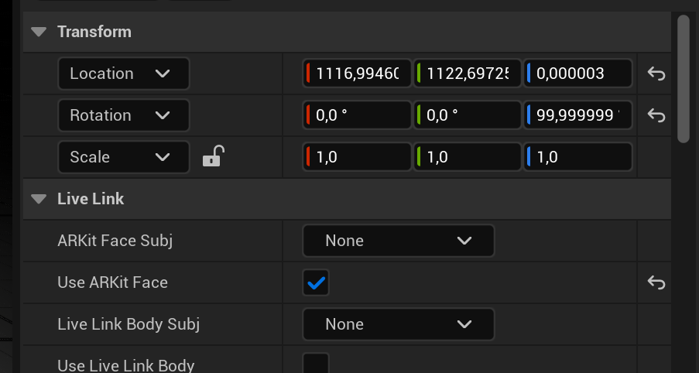
Run text_to_face.py ones, this will add face1 to ARKit Face Subj
Click on the drop down for ARKit Face Subj and select face1.
Dont forget to click Use ARKit Face…
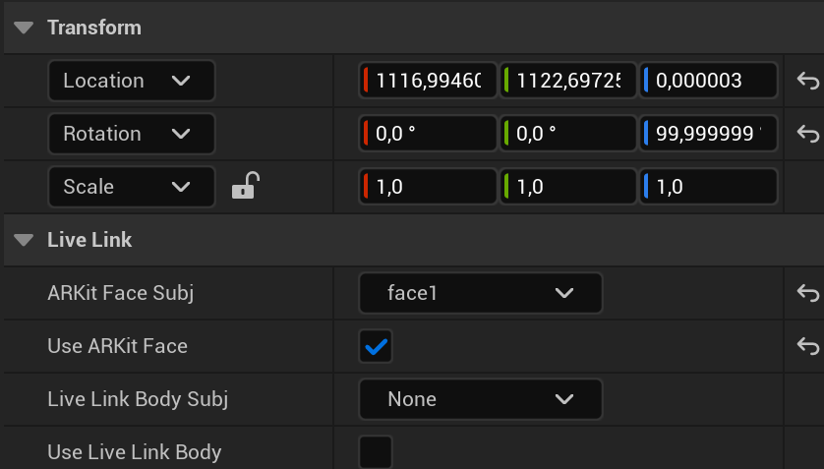
Ready, everything is configured and everything should work. Use the scripts and have fun!

Social Stream Ninja

For instructions on how to use Social Stream Ninja there are other tutorials, I will only go through how you set it up so you can send the AI Bot responses in Social Stream Ninja to Neurosync…

